TITLE OF ARTICLE TITLE OF ARTICLE TITLE OF ARTICLE TITLE OF ARTICLE TITLE OF ARTICLE

Name Surname, Name Surname, Name Surname, etc.

Article category (Authors' proposal)

Summary

Summary Summary Summary Summary Summary Summary Summary Summary Summary Summary Summary Summary Summary Summary Summary Summary Summary Summary Summary Summary Summary Summary Summary Summary Summary Summary Summary Summary Summary Summary Summary Summary Summary Summary Summary Summary Summary Summary Summary Summary Summary Summary Summary Summary Summary Summary Summary

Key words: key words, key words, key words, key words, key words

INTRODUCTION

Introduction Introduction Introduction Introduction Introduction Introduction Introduction Introduction Introduction Introduction Introduction Introduction Introduction Introduction Introduction Introduction Introduction Introduction Introduction Introduction Introduction Introduction Introduction Introduction Introduction Introduction

MATERIALS AND METHODS

Materials and Methods Materials and Methods Materials and Methods Materials and Methods Materials and Methods Materials and Methods Materials and Methods Materials and Methods Materials and Methods Materials and Methods Materials and Methods Materials and Methods Materials and Methods

RESULTS AND DISCUSSION

Results and discussion Results and discussion Results and discussion Results and discussion Results and discussion Results and discussion Results and discussion Results and discussion Results and discussion Results and discussion Results and discussion Results and discussion Results and discussion

Tab. 3. The average scores for sensory analysed wines

Wine | The average score | Cv (%)
B-1 | 16.65 ± 0.41 | 7.36
B-2 | 17.00 ± 0.40 | 7.07
B-3 | 13.90 ± 0.91 | 19.54
B-4 | 17.40 ± 0.52 | 8.96
R-1 | 17.60 ± 0.36 | 6.11
R-2 | 15.70 ± 0.42 | 7.97

Results and discussion Results and discussion Results and discussion Results and discussion Results and discussion Results and discussion Results and discussion Results and discussion

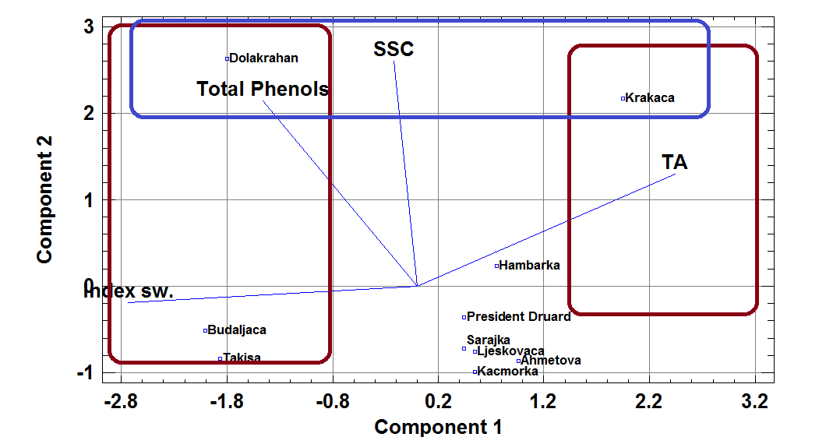

Fig. 1. Principal components analyses of studied pear cultivars with vectors of measured biochemical characteristics

Results and discussion Results and discussion Results and discussion Results and discussion Results and discussion Results and discussion Results and discussion Results and discussion Results and discussion Results and discussion

CONCLUSIONS

Conclusions Conclusions Conclusions Conclusions Conclusions Conclusions Conclusions Conclusions Conclusions Conclusions Conclusions Conclusions Conclusions Conclusions Conclusions Conclusions Conclusions Conclusions Conclusions.

REFERENCES

Article in journal, for example:

Nissen, P., Nielsen, D., Arneboug, N. (2004): The relative glucose uptake abilities of non-Saccharomyces yeasts play a role in their coexistence with Saccharomyces cerevisiae in mixed cultures. Appl. Microbiol. Biotechnol., Vol. 64, No. 4; pp. 543–550.

Book, for example:

Komić, J. (1996): Metodi statističke analize kroz primjere. Centar, Beograd, pp. 104-121.

Article in edited collection or conference proceedings, for example:

Sponholz, W. R., Hühn, T. (1996): Aging of wine: 1,1,6-Trimethyl-1,2-dihycronaphthalene (TDN) and 2-Aminoacetophenone. In: Proceedings of the 4th International Symposium on Cool Climate Viticulture and Enology (Ed: Henick-Kling, T.), New York State Agricultural Experimental Station, Geneva, NY., pp. VI-37–57.

NASLOV RADA NASLOV RADA NASLOV RADA NASLOV RADA NASLOV RADA NASLOV RADA (BHS language, will be done by the Committee)

Rezime

Rezime Rezime Rezime Rezime Rezime Rezime Rezime Rezime Rezime Rezime Rezime Rezime Rezime Rezime Rezime Rezime Rezime Rezime Rezime Rezime Rezime Rezime Rezime Rezime Rezime Rezime Rezime Rezime Rezime Rezime Rezime Rezime Rezime Rezime Rezime Rezime Rezime Rezime Rezime Rezime Rezime Rezime Rezime Rezime Rezime Rezime Rezime Rezime Rezime Rezime Rezime Rezime Rezime Rezime Rezime Rezime Rezime Rezime

Ključne riječi: ključne riječi, ključne riječi, ključne riječi, ključne riječi, ključne riječi

Name and address of the first author's institution
Name and address of the second author's institution
Name and address of the third author's institution Correspondence: Author's name, address and e-mail

